CHANGES HISTORY
PIC | Date | Remarks
BJM.MR | 2018.05.08 | Created
Ghaida | 2018.05.08

TOC
- Afa Payable Redemption Fee Transaction
- Afa Payable Charges Balance
- Afa Payable Charges Transaction
- Afa Payable Others Transaction
- Afa Payable Selling Fee Transaction
- Parameter Afa Charges
- Afa Asset Others Transaction
- Afa Payable Selling Fee Balance
- Afa Payable Redemption Fee Balance

Diagram ENTITY RELATIONSHIP

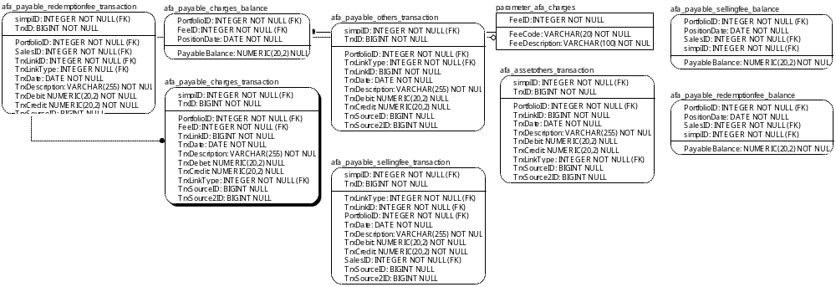

TABLE RELATIONSHIP
No | Table 1 | Table 2 | Type (1:1; 1:N; M:N) | Description
 | parameter_afa_charges | afa_payable_charges_transaction | M:N
 | parameter_afa_charges | afa_payable_charges_balance | M:N

Name |  | afa_payable_redemptionfee_transaction
Objective
No | Column |  | Type | Rule  (PK, FK, Key, NN, Unik, Index) | Description
1. | TrxID |  | Integer | FK
2. | simpiID |  | BIGInteger | NN
3. | PortfolioID |  | Integer | FK
4. | SalesID |  | Integer | FK
5. | TrxLinkID |  | Integer | FK
6. | TrxLinkType |  | Integer | FK
7. | TrxDate |  | Date | NN
8. | TrxDescription |  | Varchar(255) | NN
9. | TrxDebit |  | Numeric(20,2) | NN
10. | TrxCredit |  | Numeric(20,2) | NN
11. | TrxSourceID |  | BIGInteger | Null
12. | TrxSource2ID |  | BIGInteger | Null

SAMPLE DATA
No | Column | Sample 1 | Sample 2 | Sample 3 | Sample 4
1. | TrxID
2. | simpiID
3. | PortfolioID
4. | SalesID
5. | TrxLinkID
6. | TrxLinkType
7. | TrxDate
8. | TrxDescription
9. | TrxDebit
10. | TrxCredit
11. | TrxSourceID
12. | TrxSource2ID

Name |  | afa_payable_charges_balance
Objective
No | Column |  | Type | Rule  (PK, FK, Key, NN, Unik, Index) | Description
1. | PortfolioID |  | Integer | FK
2. | FeeID |  | Integer | FK
3. | PositionDate |  | Date | NN
4. | PayableBalance |  | Numeric(20,2) | Null

SAMPLE DATA
No | Column | Sample 1 | Sample 2 | Sample 3 | Sample 4
1. | PortfolioID | 48 | 48 | 48 | 48
2. | FeeID | 1 | 1 | 1 | 1
3. | PositionDate | 1/3/2017 | 1/4/2017 | 1/5/2017 | 1/6/2017
4. | PayableBalance | 22868429.59 | 30485531.27 | 38127336.23 | 45812568.04

Name |  | afa_payable_charges_transaction
Objective
No | Column |  | Type | Rule  (PK, FK, Key, NN, Unik, Index) | Description
1. | TrxID |  | BIGInteger | NN
2. | simpiID |  | Integer | FK
3. | PortfolioID |  | Integer | FK
4. | FeeID |  | Integer | FK
5. | TrxLinkID |  | BIGInteger | NN
7. | TrxDate |  | Date | NN
8. | TrxDescription |  | Varchar(255) | NN
9. | TrxDebit |  | Numeric(20,2) | NN
10. | TrxCredit |  | Numeric(20,2) | NN
11. | TrxLinkType |  | Integer | FK
12. | TrxSourceID |  | BIGInteger | Null
13. | TrxSource2ID |  | BIGInteger | Null

SAMPLE DATA
No | Column | Sample 1 | Sample 2 | Sample 3 | Sample 4
1. | TrxID | 5 | 7 | 9 | 11
2. | simpiID | 817 | 817 | 817 | 817
3. | PortfolioID | 92 | 92 | 92 | 92
4. | FeeID | 1.00 | 1.00 | 1.00 | 1.00
5. | TrxLinkID | 6468.00 | 6469.00 | 6470.00 | 6471.00
7. | TrxDate | 4/13/2017 | 4/17/2017 | 4/18/2017 | 4/20/2017
8. | TrxDescription | Accrual charges expense from 12-Apr-2017 to 13-Apr-2017 | Accrual charges expense from 13-Apr-2017 to 17-Apr-2017 | Accrual charges expense from 17-Apr-2017 to 18-Apr-2017 | Accrual charges expense from 18-Apr-2017 to 20-Apr-2017
9. | TrxDebit | 0.00 | 0.00 | 0.00 | 0.00
10. | TrxCredit | 2191780.82 | 8786615.71 | 0.00 | 0.00
11. | TrxLinkType | 109.00 | 109 | 109 | 109
12. | TrxSourceID | 5 | 7 | 9 | 11
13. | TrxSource2ID | 817 | 817 | 817 | 817

Name |  | afa_payable_others_transaction
Objective
No | Column |  | Type | Rule  (PK, FK, Key, NN, Unik, Index) | Description
1. | TrxID |  | BIGInteger | NN
2. | simpiID |  | Integer | FK
3. | PortfolioID |  | Integer | FK
4. | TrxLinkID |  | BIGInteger | NN
5. | TrxDate |  | Date | NN
6. | TrxDescription |  | Varchar(255) | NN
7. | TrxDebit |  | Numeric(20,2) | NN
8. | TrxCredit |  | Numeric(20,2) | NN
9. | TrxLinkType |  | Integer | FK
10. | TrxSourceID |  | BIGInteger | Null
11. | TrxSource2ID |  | BIGInteger | Null

SAMPLE DATA
No | Column |  | Sample 1 | Sample 2 | Sample 3 | Sample 4
1. | TrxID
2. | simpiID
3. | PortfolioID
4. | TrxLinkID
5. | TrxDate
7. | TrxDescription
8. | TrxDebit
9. | TrxCredit
10. | TrxLinkType
11. | TrxSourceID
Name |  | afa_payable_sellingfee_transaction
Objective
No | Column |  | Type | Rule  (PK, FK, Key, NN, Unik, Index) | Description
1. | TrxID |  | BIGInteger | NN
2. | simpiID |  | Integer | FK
3. | PortfolioID |  | Integer | FK
4. | SalesID |  | Integer | FK
5. | TrxLinkID |  | BIGInteger | NN
6. | TrxDate |  | Date | NN
7. | TrxDescription |  | Varchar(255) | NN
8. | TrxDebit |  | Numeric(20,2) | NN
9. | TrxCredit |  | Numeric(20,2) | NN
10. | TrxLinkType |  | Integer | FK
11. | TrxSourceID |  | BIGInteger | Null
12. | TrxSource2ID |  | BIGInteger | Null

SAMPLE DATA
No | Column | Sample 1 | Sample 2 | Sample 3 | Sample 4
1. | TrxID
2. | simpiID
3. | PortfolioID
4. | SalesID
5. | TrxLinkID
6. | TrxDate
7. | TrxDescription
8. | TrxDebit
9. | TrxCredit
10. | TrxLinkType
11. | TrxSourceID
12. | TrxSource2ID

Name |  | Parameter_afa_charges
Objective
No | Column |  | Type | Rule  (PK, FK, Key, NN, Unik, Index) | Description
1. | FeeID |  | Integer | NN
2. | FeeCode |  | Varchar(20) | NN
3. | FeeDescription |  | Varchar(100) | NN

SAMPLE DATA
No | Column | Sample 1 | Sample 2 | Sample 3 | Sample 4
1. | FeeID | 1 | 2 | 3 | 4
2. | FeeCode | Management | Custodian | Audit | Commission
3. | FeeDescription | Management Fee | Custodian Fee | Audit Fee | Equities Broker Commission

Name |  | afa_payable_assetothers_transaction
Objective
No | Column |  | Type | Rule  (PK, FK, Key, NN, Unik, Index) | Description
1. | simpiID |  | Integer | FK
2. | TrxID |  | BIGInteger | NN
3. | PortfolioID |  | Integer | FK
4. | TrxLinkID |  | BIGInteger | NN
5. | TrxDate |  | Date | NN
6. | TrxDescription |  | Varchar(255) | NN
7. | TrxDebit |  | Numeric(20,2) | NN
8. | TrxCredit |  | Numeric(20,2) | NN
9. | TrxLinkType |  | Integer | FK
10. | TrxSourceID |  | BIGInteger | Null
11. | TrxSource2ID |  | BIGInteger | Null

SAMPLE DATA
No | Column | Sample 1 | Sample 2 | Sample 3 | Sample 4
1. | simpiID
2. | TrxID
3. | PortfolioID
4. | TrxLinkID
5. | TrxDate
7. | TrxDescription
8. | TrxDebit
9. | TrxCredit
10. | TrxLinkType
11. | TrxSourceID

Name |  | afa_payable_sellingfee_balance
Objective
No | Column |  | Type | Rule  (PK, FK, Key, NN, Unik, Index) | Description
1. | PortfolioID |  | Integer | FK
2. | SalesID |  | Integer | FK
3. | PositionDate |  | Date | NN
4. | PayableBalance |  | Numeric(20,2) | NN

SAMPLE DATA
No | Column | Sample 1 | Sample 2 | Sample 3 | Sample 4
1. | PortfolioID
2. | SalesID
3. | PositionDate
4. | PayableBalance

Name |  | afa_payable_redemptionfee_balance
Objective
No | Column |  | Type | Rule  (PK, FK, Key, NN, Unik, Index) | Description
1. | PortfolioID |  | Integer | FK
2. | SalesID |  | Integer | FK
3. | PositionDate |  | Date | NN
4. | PayableBalance |  | Numeric(20,2) | NN

SAMPLE DATA
No | Column | Sample 1 | Sample 2 | Sample 3 | Sample 4
1. | PortfolioID
2. | SalesID
3. | PositionDate
4. | PayableBalance

